Network Adjustment Report
Project : City of Lubbock 2010 Orthophotos
Lake Alan Henry Panels
User name | R Christopher | Date & Time | 11:17:30 AM 3/1/2010
Coordinate System | US State Plane 1983 | Zone | Texas North Central 4202
Project Datum | NAD 1983 (Conus)
Vertical Datum |  | Geoid Model | Geoid03HRA
Coordinate Units | US survey feet
Distance Units | US survey feet
Height Units | US survey feet

Adjustment Style Settings - 95% Confidence Limits
Residual Tolerances
To End Iterations | : | 0.000033sft
Final Convergence Cutoff | : | 0.016404sft
Covariance Display
Horizontal
Propagated Linear Error [E] | : | U.S.
Constant Term [C] | : | 0.00000000sft
Scale on Linear Error [S] | : | 1.96

Three-Dimensional
Propagated Linear Error [E] | : | U.S.
Constant Term [C] | : | 0.00000000sft
Scale on Linear Error [S] | : | 1.96
Elevation Errors were used in the calculations.
Adjustment Controls
Compute Correlations for Geoid | : | False
Horizontal and Vertical adjustment performed
Set-up Errors
GPS
Error in Height of Antenna | : | 0.005sft
Centering Error | : | 0.003sft
Back to top

Statistical Summary
Successful Adjustment in 2 iteration(s)
Network Reference Factor | : | 1.19
Chi Square Test (α=95%) | : | PASS
Degrees of Freedom | : | 15.00
GPS Observation Statistics
Reference Factor | : | 1.19
Redundancy Number (r) | : | 15.00
Individual GPS Observation Statistics
Observation ID | Reference Factor | Redundancy Number
B1 | 2.43 | 0.16
B2 | 0.79 | 1.19
B3 | 0.38 | 0.75
B4 | 0.31 | 1.07
B5 | 0.05 | 0.72
B6 | 1.85 | 1.49
B7 | 0.55 | 1.93
B8 | 0.05 | 1.67
B9 | 2.29 | 2.24
B10 | 0.86 | 2.29
B11 | 0.31 | 1.47
Geoid Model Statistics
Reference Factor | : | 1.00
Redundancy Number (r) | : | 0.00
Weighting Strategies
GPS Observations
User-defined Scalar Applied to All Observations
Scalar | : | 9.33
Geoid Observations
Alternative Scalar Applied to All Observations
Scalar | : | 1.00

Adjusted Coordinates
Adjustment performed in NAD 1983 (Conus)
Number of Points | : | 7
Number of Constrained Points | : | 1
Horizontal plus Height and Elevation | : | 1
Adjusted Grid Coordinates
Errors are reported using 1.96.
Point Name | Northing | N error | Easting | E error | Elevation | e error | Fix
2098 | 7083766.085sft | 0.000sft | 1185284.222sft | 0.000sft | 2303.532sft | 0.000sft | N E h e
82048 | 7094301.571sft | 0.045sft | 1190631.496sft | 0.038sft | 2321.676sft | 2.469sft
2062 | 7084003.704sft | 0.079sft | 1179112.134sft | 0.064sft | 2363.585sft | 2.477sft
2049 | 7089462.164sft | 0.082sft | 1190572.817sft | 0.068sft | 2319.599sft | 2.483sft
2099 | 7074217.352sft | 0.088sft | 1176682.525sft | 0.069sft | 2253.498sft | 2.485sft
2061 | 7062823.368sft | 0.116sft | 1190741.416sft | 0.086sft | 2299.150sft | 2.486sft
TXLU | 7257752.795sft | 0.073sft | 950076.199sft | 0.058sft | 3221.800sft | 2.477sft
Adjusted Geodetic Coordinates
Errors are reported using 1.96.
Point Name | Latitude | N error | Longitude | E error | Height | h error | Fix
2098 | 33°04'31.97414"N | 0.000sft | 101°03'26.07169"W | 0.000sft | 2219.080sft | 0.000sft | Lat Long h e
82048 | 33°06'17.47635"N | 0.045sft | 101°02'26.23764"W | 0.038sft | 2237.298sft | 0.106sft
2062 | 33°04'32.83232"N | 0.079sft | 101°04'38.65914"W | 0.064sft | 2279.349sft | 0.227sft
2049 | 33°05'29.59018"N | 0.082sft | 101°02'25.55157"W | 0.068sft | 2235.156sft | 0.285sft
2099 | 33°02'55.43400"N | 0.088sft | 101°05'04.37641"W | 0.069sft | 2169.169sft | 0.301sft
2061 | 33°01'06.11357"N | 0.116sft | 101°02'16.00638"W | 0.086sft | 2214.340sft | 0.310sft
TXLU | 33°32'07.49023"N | 0.073sft | 101°50'34.16386"W | 0.058sft | 3140.359sft | 0.229sft
Coordinate Deltas
Point Name | ΔNorthing | ΔEasting | ΔElevation | ΔHeight | ΔGeoid Separation
2098 | 0.000sft | 0.000sft | 0.000sft | 0.000sft | 0.000sft
82048 | 0.004sft | -0.001sft | 0.080sft | 0.080sft | 0.000sft
2062 | -0.002sft | 0.000sft | -0.028sft | -0.028sft | 0.000sft
2049 | -0.001sft | -0.003sft | 0.056sft | 0.056sft | 0.000sft
2099 | -0.009sft | -0.002sft | -0.081sft | -0.081sft | 0.000sft
2061 | -0.007sft | 0.002sft | -0.087sft | -0.087sft | 0.000sft
TXLU | -0.042sft | -0.066sft | 0.000sft | 0.000sft | 0.000sft

Control Coordinate Comparisons
Values shown are control coord minus adjusted coord.
Point Name | ΔNorthing | ΔEasting | ΔElevation | ΔHeight
2098 | N/A | N/A | N/A | N/A
TXLU | 0.042sft | 0.066sft | N/A | 0.000sft

Adjusted Observations
Adjustment performed in NAD 1983 (Conus)
GPS Observations
Number of Observations | : | 11
Number of Outliers | : | 0
Observation Adjustment (Critical Tau = 2.83). Any outliers are in red.
Obs.  ID | From Pt. | To Pt. |  | Observation | A-posteriori Error  (1.96σ) | Residual | Stand.  Residual
B1 | 2098 | 82048 | Az. | 25°30'55.1125" | 0°00'00.6389" | 0°00'00.0561" | 0.76
 |  |  | ΔHt. | 18.218sft | 0.106sft | 0.028sft | 2.38
 |  |  | Dist. | 11816.315sft | 0.046sft | 0.015sft | 2.30
B6 | TXLU | 2098 | Az. | 124°39'56.8594" | 0°00'00.0487" | -0°00'00.0187" | -0.80
 |  |  | ΔHt. | -921.279sft | 0.229sft | 0.329sft | 2.37
 |  |  | Dist. | 292598.463sft | 0.063sft | -0.004sft | -0.13
B9 | 82048 | TXLU | Az. | 302°48'38.2467" | 0°00'00.0553" | 0°00'00.0952" | 1.93
 |  |  | ΔHt. | 903.061sft | 0.239sft | 0.427sft | 2.29
 |  |  | Dist. | 290865.004sft | 0.069sft | -0.072sft | -0.99
B10 | 2062 | TXLU | Az. | 305°46'46.6579" | 0°00'00.0460" | -0°00'00.0473" | -0.98
 |  |  | ΔHt. | 861.010sft | 0.237sft | 0.110sft | 0.59
 |  |  | Dist. | 287515.563sft | 0.063sft | 0.012sft | 0.19
B2 | 2098 | 2062 | Az. | 270°48'36.1201" | 0°00'02.6412" | -0°00'01.0104" | -0.76
 |  |  | ΔHt. | 60.269sft | 0.227sft | -0.011sft | -0.12
 |  |  | Dist. | 6177.447sft | 0.063sft | 0.022sft | 0.79
B7 | TXLU | 2049 | Az. | 123°09'27.9703" | 0°00'00.0401" | 0°00'00.0016" | 0.07
 |  |  | ΔHt. | -905.203sft | 0.241sft | 0.144sft | 0.64
 |  |  | Dist. | 293564.446sft | 0.055sft | 0.001sft | 0.02
B3 | 2062 | 2049 | Az. | 63°07'36.8352" | 0°00'00.8732" | 0°00'00.0179" | 0.08
 |  |  | ΔHt. | -44.193sft | 0.245sft | -0.043sft | -0.46
 |  |  | Dist. | 12695.789sft | 0.052sft | 0.003sft | 0.17
B11 | TXLU | 2099 | Az. | 127°10'48.4684" | 0°00'00.0359" | 0°00'00.0022" | 0.17
 |  |  | ΔHt. | -971.190sft | 0.236sft | -0.057sft | -0.23
 |  |  | Dist. | 291642.496sft | 0.048sft | 0.006sft | 0.37
B4 | 2049 | 2099 | Az. | 220°57'09.5387" | 0°00'00.6015" | 0°00'00.1046" | 0.36
 |  |  | ΔHt. | -65.987sft | 0.209sft | -0.003sft | -0.04
 |  |  | Dist. | 20626.508sft | 0.059sft | -0.002sft | -0.08
B8 | TXLU | 2061 | Az. | 127°10'52.0358" | 0°00'00.0585" | -0°00'00.0011" | -0.03
 |  |  | ΔHt. | -926.019sft | 0.236sft | -0.008sft | -0.08
 |  |  | Dist. | 309741.078sft | 0.073sft | -0.001sft | -0.02
B5 | 2099 | 2061 | Az. | 127°36'47.9961" | 0°00'00.9310" | 0°00'00.0077" | 0.03
 |  |  | ΔHt. | 45.171sft | 0.184sft | 0.003sft | 0.08
 |  |  | Dist. | 18098.583sft | 0.066sft | 0.000sft | 0.02
Geoid Observations
Number of Observations | : | 6
Number of Outliers | : | 0
Observation Adjustment (Critical Tau = 2.83). Any outliers are in red.
Observation ID | Point Name | Separation | A-posteriori Error  (1.96σ) | Residual | Standardized  Residual
G7 | TXLU | -81.441sft | 2.466sft | 0.000sft | 0.00
G1 | 2098 | ? | ? | ? | ?
G2 | 82048 | -84.378sft | 2.466sft | 0.000sft | 0.00
G3 | 2062 | -84.236sft | 2.466sft | 0.000sft | 0.00
G4 | 2049 | -84.443sft | 2.466sft | 0.000sft | 0.00
G5 | 2099 | -84.329sft | 2.466sft | 0.000sft | 0.00
G6 | 2061 | -84.810sft | 2.466sft | 0.000sft | 0.00

Histograms of Standardized Residuals
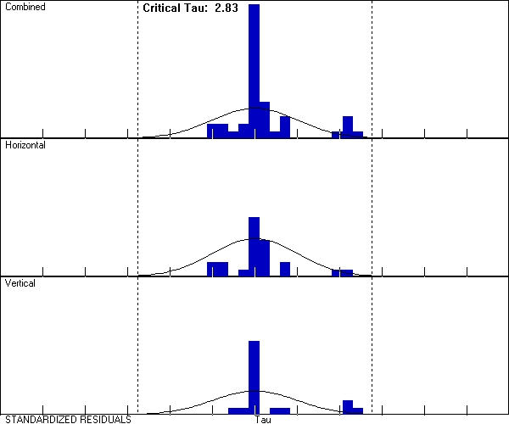

Point Error Ellipses
82048 | 2062 | 2049
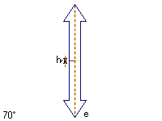 | 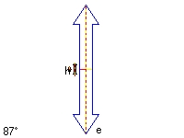 | 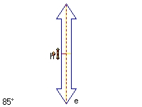
Tick Size: 0.1000sft Horizontal Bivariate Scalar: 2.45σ Vertical Univariate Scalar: 1.96σ
2099 | 2061 | TXLU
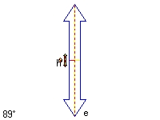 | 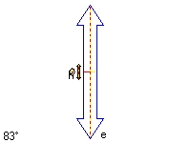 | 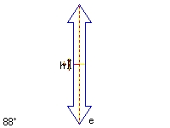
Tick Size: 0.1000sft Horizontal Bivariate Scalar: 2.45σ Vertical Univariate Scalar: 1.96σ

Covariant Terms
Adjustment performed in NAD 1983 (Conus)
From Point | To Point |  | Components | A-posteriori Error  (1.96σ) | Horiz. Precision  (Ratio) | 3D Precision  (Ratio)
2098 | 82048 | Az. | 25°30'55.1125" | 0°00'00.6389" | 1:255438 | 1:255438
 |  | ΔHt. | 18.218sft | 0.106sft
 |  | ΔElev. | 18.144sft | 2.469sft
 |  | Dist. | 11816.315sft | 0.046sft
2098 | 2062 | Az. | 270°48'36.1201" | 0°00'02.6412" | 1:97284 | 1:97284
 |  | ΔHt. | 60.269sft | 0.227sft
 |  | ΔElev. | 60.053sft | 2.477sft
 |  | Dist. | 6177.447sft | 0.063sft
2098 | TXLU | Az. | 305°05'49.8022" | 0°00'00.0485" | 1:4671455 | 1:4671455
 |  | ΔHt. | 921.279sft | 0.229sft
 |  | ΔElev. | 918.268sft | 2.477sft
 |  | Dist. | 292598.463sft | 0.063sft
82048 | TXLU | Az. | 302°48'38.2467" | 0°00'00.0553" | 1:4209079 | 1:4209079
 |  | ΔHt. | 903.061sft | 0.239sft
 |  | ΔElev. | 900.123sft | 3.497sft
 |  | Dist. | 290865.004sft | 0.069sft
2062 | 2049 | Az. | 63°07'36.8352" | 0°00'00.8732" | 1:243003 | 1:243003
 |  | ΔHt. | -44.193sft | 0.245sft
 |  | ΔElev. | -43.986sft | 3.507sft
 |  | Dist. | 12695.789sft | 0.052sft
2062 | TXLU | Az. | 305°46'46.6579" | 0°00'00.0460" | 1:4529240 | 1:4529240
 |  | ΔHt. | 861.010sft | 0.237sft
 |  | ΔElev. | 858.215sft | 3.503sft
 |  | Dist. | 287515.563sft | 0.063sft
2049 | 2099 | Az. | 220°57'09.5387" | 0°00'00.6015" | 1:352299 | 1:352299
 |  | ΔHt. | -65.987sft | 0.209sft
 |  | ΔElev. | -66.101sft | 3.512sft
 |  | Dist. | 20626.508sft | 0.059sft
2049 | TXLU | Az. | 303°35'54.4825" | 0°00'00.0400" | 1:5317371 | 1:5317371
 |  | ΔHt. | 905.203sft | 0.241sft
 |  | ΔElev. | 902.201sft | 3.507sft
 |  | Dist. | 293564.446sft | 0.055sft
2099 | 2061 | Az. | 127°36'47.9961" | 0°00'00.9310" | 1:272181 | 1:272181
 |  | ΔHt. | 45.171sft | 0.184sft
 |  | ΔElev. | 45.652sft | 3.515sft
 |  | Dist. | 18098.583sft | 0.066sft
2099 | TXLU | Az. | 307°35'46.8971" | 0°00'00.0357" | 1:6037734 | 1:6037734
 |  | ΔHt. | 971.190sft | 0.236sft
 |  | ΔElev. | 968.302sft | 3.508sft
 |  | Dist. | 291642.496sft | 0.048sft
2061 | TXLU | Az. | 307°37'22.2477" | 0°00'00.0583" | 1:4226056 | 1:4226056
 |  | ΔHt. | 926.019sft | 0.236sft
 |  | ΔElev. | 922.650sft | 3.509sft
 |  | Dist. | 309741.078sft | 0.073sft

