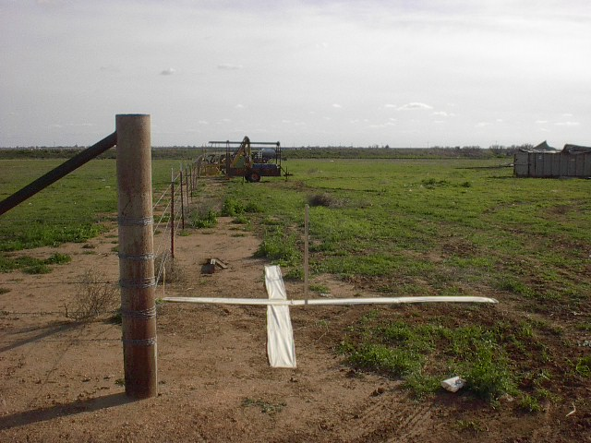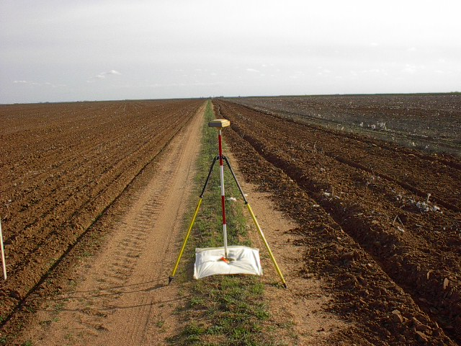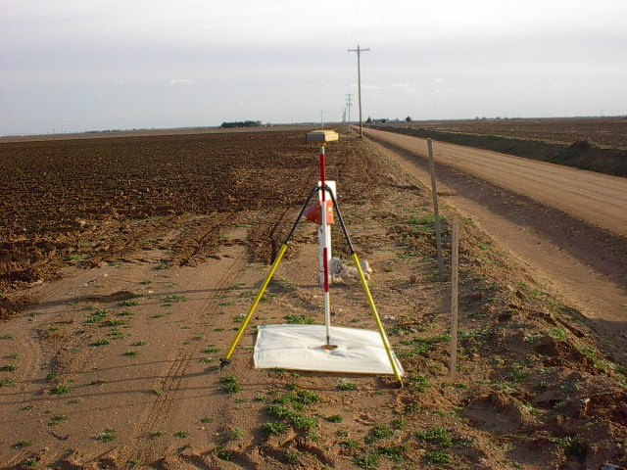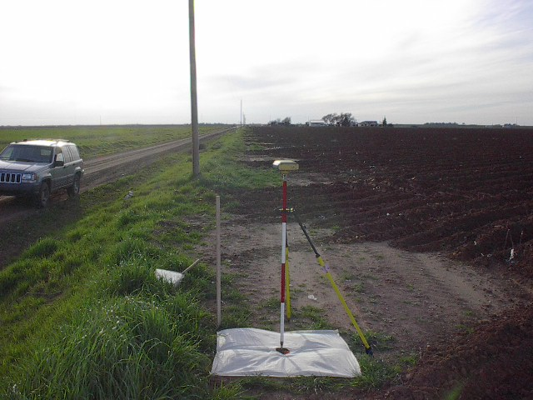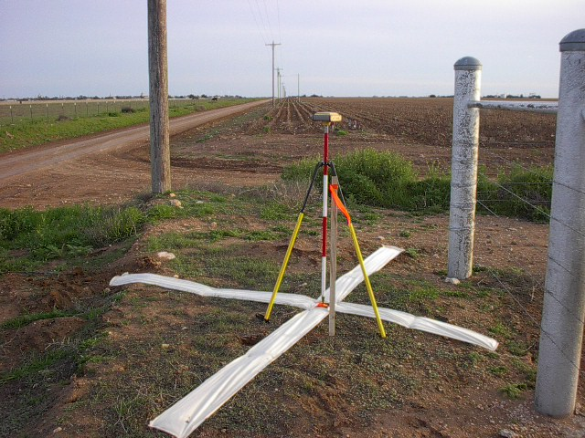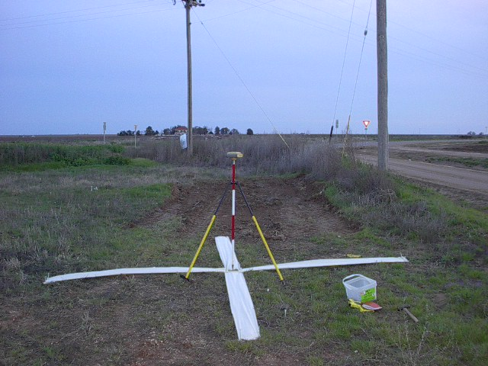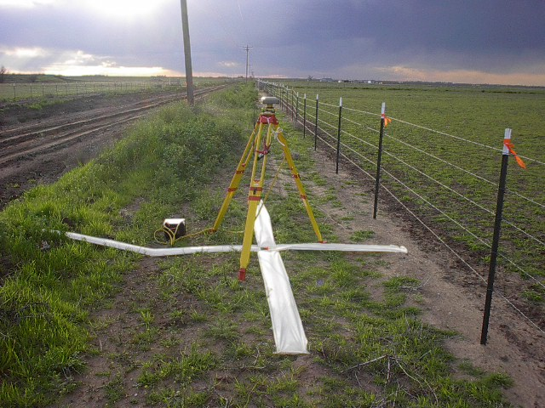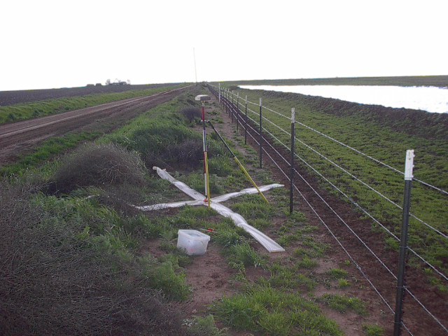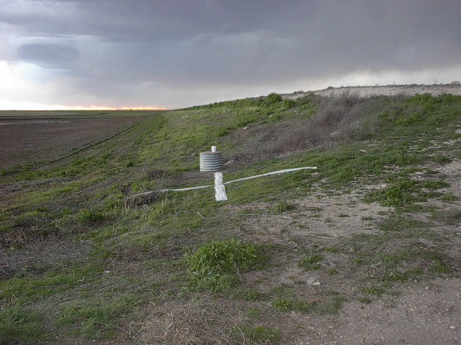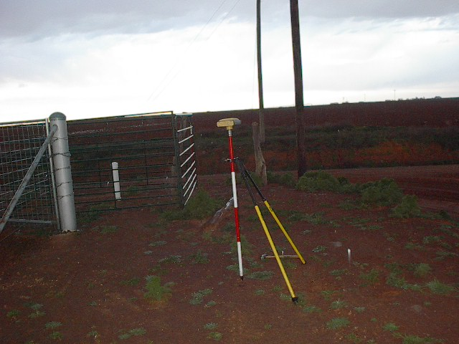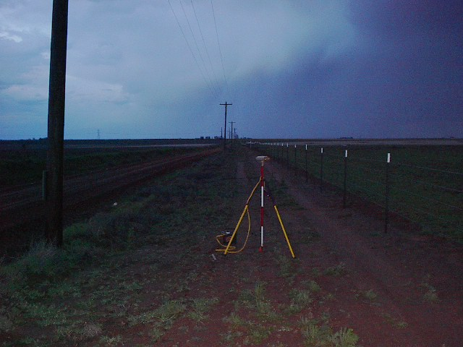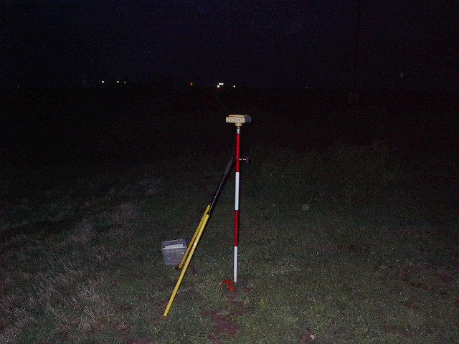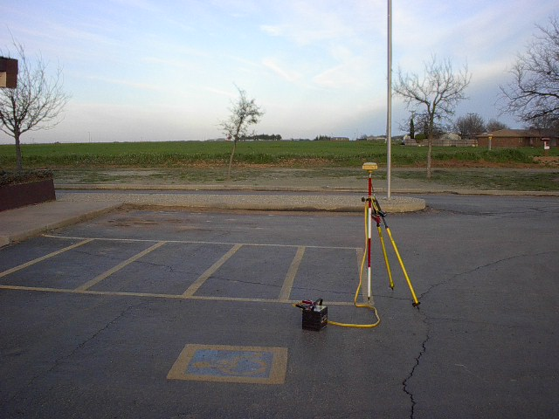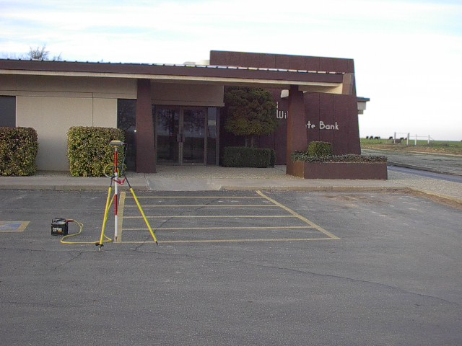
2097 Aluminum cap on rebar in concrete monument at East line of farm maintenance area; 29’ South of center of dirt road; 9.5’ SW of fence corner post; 3.9’ West of fence line’ 228.6’ East of NE corner of farm maintenance building; view looking South
2042 RR spike in center of farm lane; no references available; view looking South
2041 RR spike on edge of farm field; 30’ East of center of dirt road; 13.5’ West of pvc stand pipe up 2’; 6.7’ North of gas line vent pipe marker up 3’; view looking South
2044 RR spike on edge of farm field; 27’ North of center of dirt road; 40.4’ East of pole; view looking West
2043 RR spike on edge of farm field at NW corner of dirt road intersection; 33.5’ West of center of dirt road; 15.7’ NNW of pole; 5.3’ NE of metal fence corner post; view looking South
2046 RR spike on East side of dirt road just North of intersection with FM400; 35’ East of centerline of dirt road; 29.5’ NE of pole; 74.5’ NW of pole; 32.2; SW of SW end of South concrete leg of abandoned oil tank; view looking South
2040 Rebar on North side of dirt road West of maintenance building; 50.5’ East of pole; 4.5’ South of fence; view looking West
2039 RR spike on West side of dirt road; 20’ South of pole; 4’ East of fence; view looking South
2045 RR spike on West side of dirt road at entrance to monitoring well and pond; 39.5’ SW of North gate post; 42.6’ NW of South gate post; 10.5’ East of monitoring well; view looking West
2037 RR spike at the Southwest corner of an intersection of two dirt roads; 8’ South and 8’ East of round steel fence corner post; view looking North
2038 RR spike on the South side of a dirt road; opposite a pole up 8’ in the air and 7.4’ North of a fence; view looking East
2036 RR spike on the South side of a dirt road 75’ +/- of a field entrance to the South; 30’ +/- South of center od dirt road; view looking East
#2047Centerline centerline intersection of paint stripes at South side of bank entrance and East side of handicap stall; view looking East
#2047Additional view; Centerline centerline intersection of paint stripes at South side of bank entrance and East side of handicap stall; view looking North

