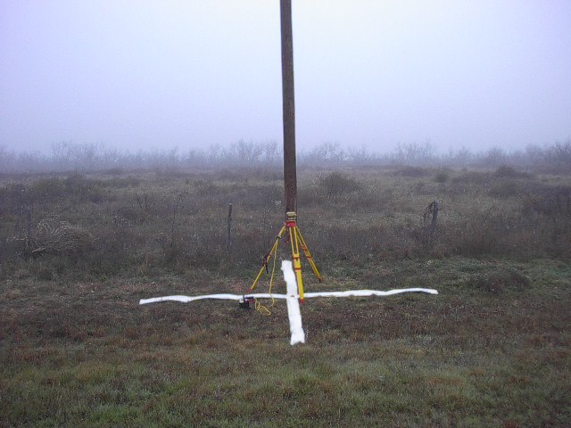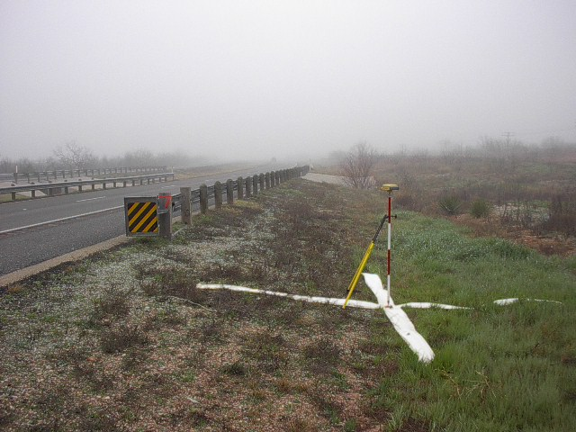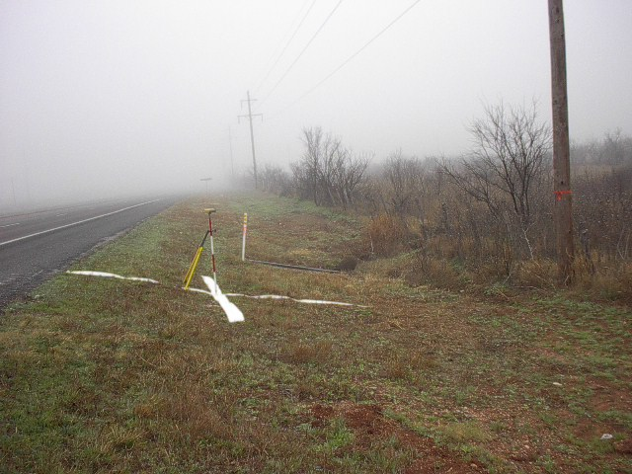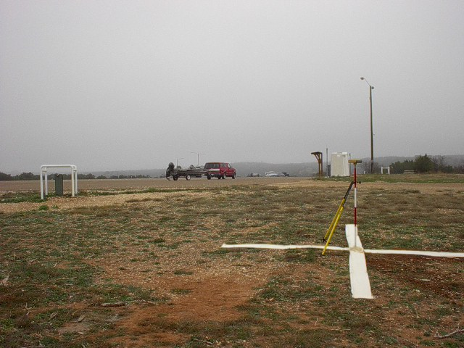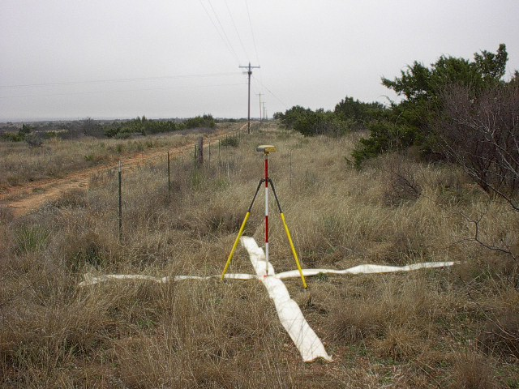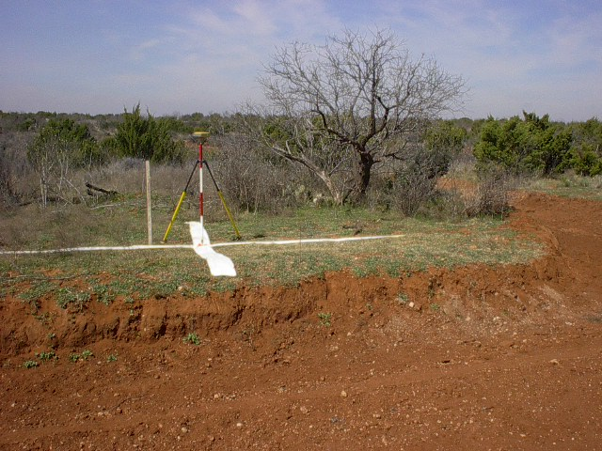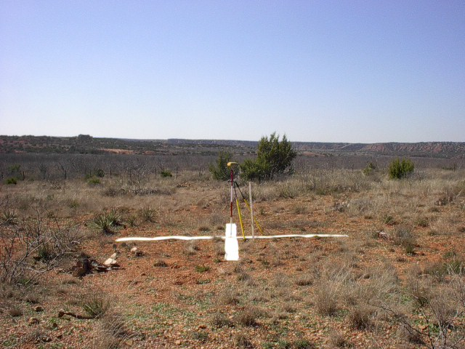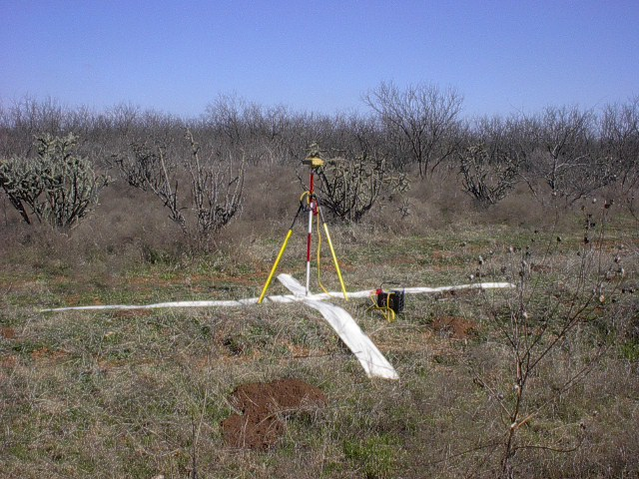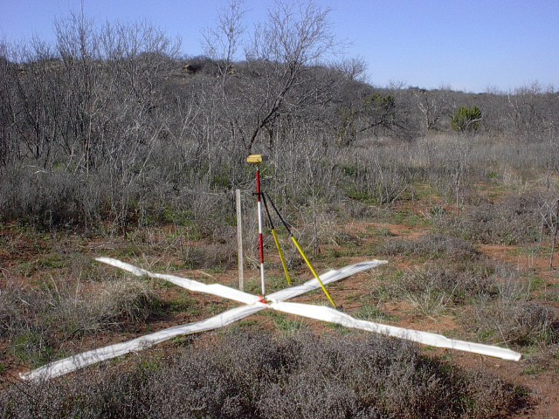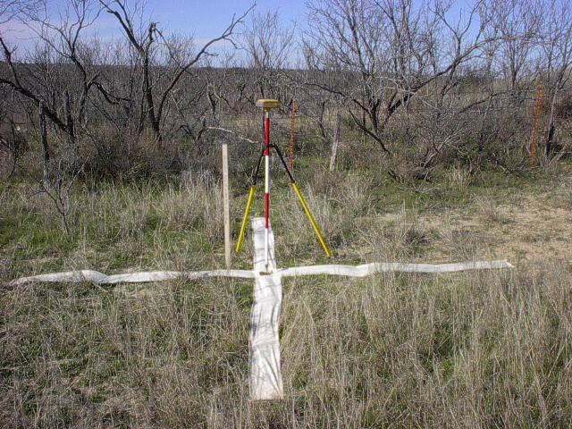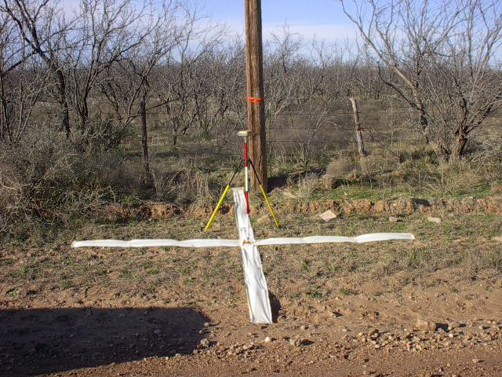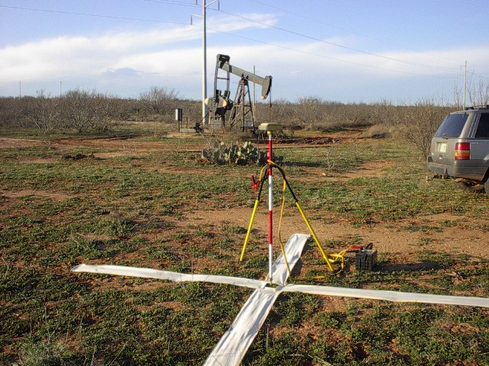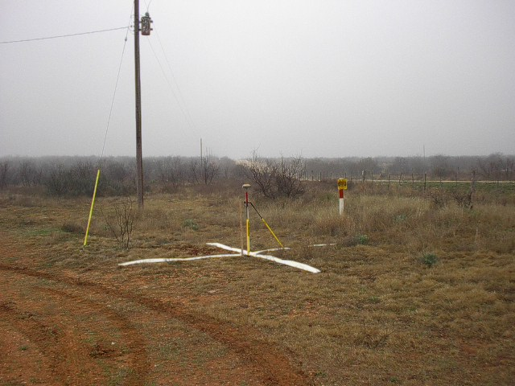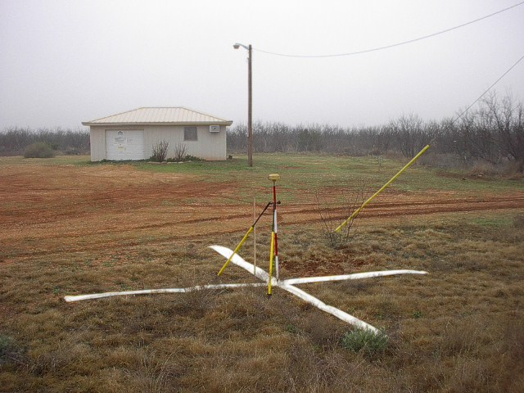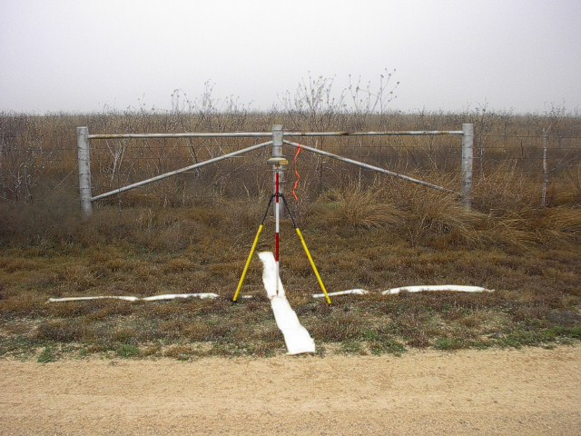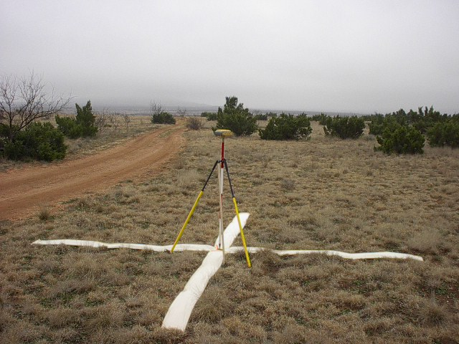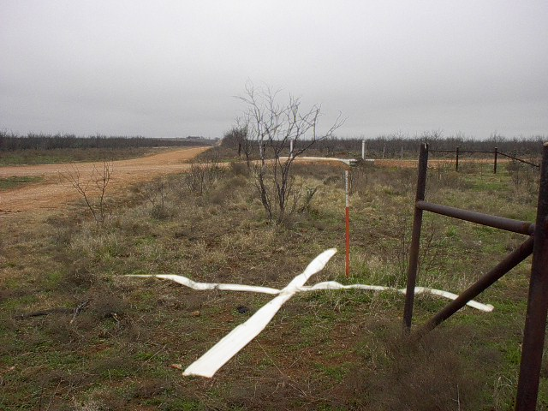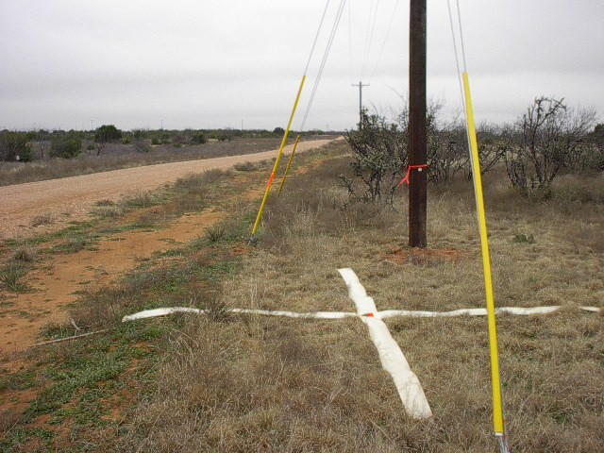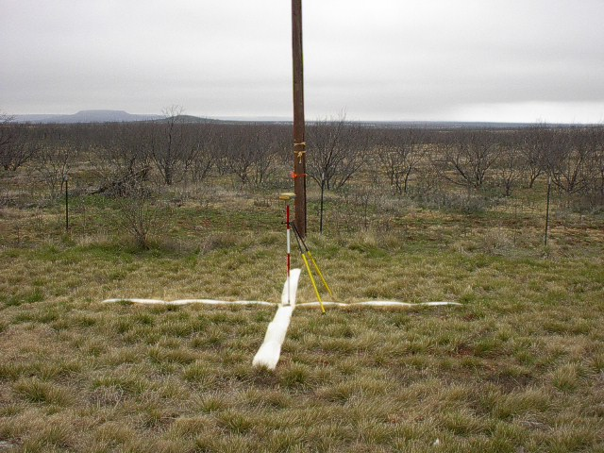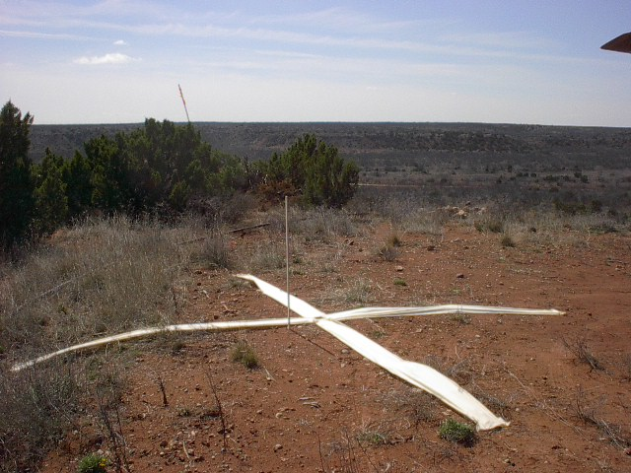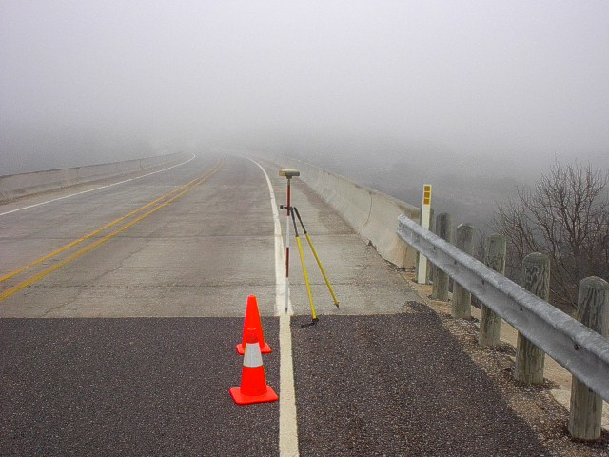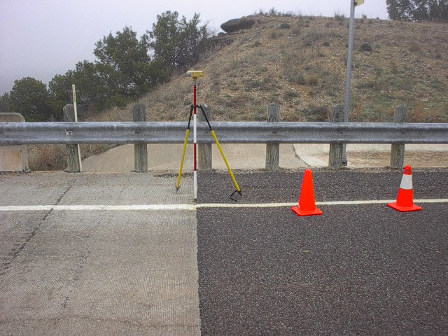
2059 Rebar on North side of FM2458 just East of highway 84; 42.8’ North of centerline; 9.3’ South of pole; 30.7’ ENE of stop sign; view looking North
2060 RR spike on West side of highway 84 just North of a culvert crossing; 25’ West of West edge of South bound paint stripes on main road; 14.4’ NNW of Northern most post on North end of guard rail on West side of road; view looking Southeast
2061 RR spike on West side of highway 84 just North of 2nd culvert crossing North of FM 1269; 19’ West of West edge of South bound paint stripes on main road; 28.5’ NNW of centerline of concrete headwall; 21.1’ ENE of pole; view looking Southeast
2099 Aluminum cap on rebar in concrete monument off the Southwest corner of the parking lot to the boat ramp area at Lake Henry; 29.4’ SW of corner of asphalt lot; 176.2’ West fo security lite; 31.9’ SW of SW stand pipe protecting riser junction box; view looking East
2049 RR spike set on East side of Lake Henry area 6.9’ West of east property line fence and 28.7’ South of a pole; access by Lake personnel escort only; view looking South
82048 RR spike set on North side of a dirt road 24’ North of centerline and 27’ West of the centerline of a graded out dirt area; view looking North
2054 RR spike set on West side of a dirt road 30’ West of centerline and 1/4 mile South of a fork in the road; No other references available; view looking West
2053 RR spike set on East side of a dirt lane 30’ West of centerline and 1/2 mile South of a “y” fork in the road; No other references available; view looking East
2048 RR spike set; No references available; view looking North
2056 RR spike set 13’ South of fence at curve in road approximately 250’ West of big hill; No other references available; view looking North
2057 RR spike set 22.5’ North of the centerline of a dirt road; 6.5’ SSW of a pole; view looking North
2064 RR spike set 110’ SSE of well head pump area; No other references available; view looking NorthNW
2098 Aluminum cap on rebar set in concrete monument near Wildlife Office; 34.9’ North of pole; 44.9’ East of southern most white 6” round steel fence post South of main gate to office; 18.6’ NE of gas line marker; view looking South
2098 Additional view looking East; Aluminum cap on rebar set in concrete monument near Wildlife Office; 34.9’ North of pole; 44.9’ East of southern most white 6” round steel fence post South of main gate to office; 18.6’ NE of gas line marker;
2062 RR spike set on North side of access road to Wildlife Office at brace fence posts; 10.9’ South of middle post; 15.1’ SW of post; 14.1’ SE of post; view looking North
2052 RR spike set on West side of dirt lane; No references available; view looking South
NGS PID AE6873 Monument found; view looking North
2051 RR spike set on North side of dirt road to subdivision area; between pole and guy wire; view looking West
2063 RR spike set on West side of FM 1142 at 15.1’ East of a pole; 36.5’ West of centerline of road; view looking West
72048 RR spike set on top of hill North of a drilling site and North of the river; no references available; view looking SouthSW
2058 Nothing set at photo id point as center of white paint line at pavement change from concrete to asphalt on new bridge; view looking WestSW
2058 Additional view looking North; Nothing set at photo id point as center of white paint line at pavement change from concrete to asphalt on new bridge;

