
The City of Lubbock, TX

LiDAR Campaign (City of Lubbock, TX)
Report of Survey

2011

EXECUTIVE SUMMARY
The City of Lubbock contracted with Sanborn to provide LiDAR mapping services for Lubbock, TX. Utilizing multi-return systems, Light Detection and Ranging (LiDAR) data in the form of 3-dimensional positions of a dense set of mass points was collected for approximately 419 square miles between March 3rd 2011 and March 6th 2011. All systems consist of geodetic GPS positioning, orientation derived from high-end inertial sensors and high-accurate lasers. The sensor is attached to the aircraft’s underside and emits rapid pulses of light that are used to determine distances between the plane and terrain below.
Specifically, the Leica ALS-50 system was used to collect data for the survey campaign. The LiDAR system is calibrated by conducting flight passes over a known ground surface before and after each LiDAR mission. During final data processing, the calibration parameters are inserted into post-processing software.
Four airborne GPS (Global Positioning System) base stations were used in the Lubbock project. NGS points with PID’s of DP0297, AC9160 were used as monuments for the GPS base station placement. As well as two Sanborn placed points 500 and 501. These four base stations were tied to each other to create a GPS survey network. The coordinates of these stations were checked against each other with the three dimensional GPS baseline created at the airborne support set up and determined to be within project specifications.
The acquired LiDAR data was processed to obtain first and last return point data. The last return data was further filtered to yield a LiDAR surface representing the bare earth.
Contents
1.0 INTRODUCTION 4
1.1 Contact Information 4
1.2 Purpose of the LiDAR Acquisition 4
1.3 Project Location 4
1.4 Standard Specifications for LiDAR 5
2.0 LiDAR CALIBRATION 6
2.1 Introduction 6
2.2 Calibration Procedures 6
3.0 LiDAR FLIGHT AND SYSTEM REPORT 7
3.1 Introduction 7
3.2 Field Work Procedures 7
3.3 Final LiDAR Processing 8
4.0 GEODETIC authentication 9
4.1 Final LiDAR Verification 9
5.0 Coordinates and Datum 10
5.1 Introduction 11
5.2 Horizontal Datum 11
5.3 Vertical Datum 11

List of Tables

Table 1: LiDAR Specifications 5
Table 2: LiDAR Acquisition Parameters 7
Table 3: Collection Dates, Times, Average Per Flight Collection Parameters and PDOP 8
Table 4: Processing Accuracies and Requirements 8
Table 5: LiDAR Accuracy Assessment based on the Checkpoint Survey (Feet) 10

List of Figures
Figure 1: Area of Collection 4
Figure 2: TerraMatch Tiling Sample 6
Figure 3: Lee Survey Checkpoint Diagram 9

1.0 INTRODUCTION

This document contains the technical write-up of the LiDAR campaign, including standard specifications, system calibration techniques, field procedures, and the accuracy of the LiDAR data.

1.1 Contact Information
Questions regarding the technical aspects of this report should be addressed to:

Kathleen Crawford
Project Manager
Sanborn Map Co., Inc.
1935 Jamboree Dr. Suite 100
Colorado Springs Co 80920
719-264-5645 (Desk)
kcrawford@sanborn.com

1.2 Purpose of the LiDAR Acquisition
As stated in the Statement of Work for Acquisition and Production of High Resolution Elevation data for the Lubbock project, this LiDAR operation was designed to create high resolution data sets that will establish an authoritative source for elevation information for The City of Lubbock.

1.3 Project Location
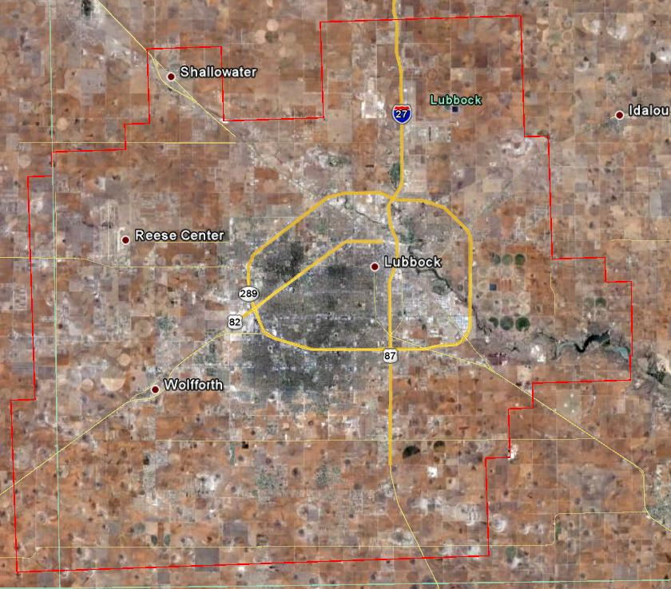

Figure 1: Area of Collection

1.4 Standard Specifications for LiDAR
Table 1: LiDAR Specifications

Data Acquisition
Requirement | Description
Returns per pulse | LiDAR sensor shall be capable of recording up to 3 (or more) returns per pulse, including 1st and last returns
Scan angle | ≤ ±20 degrees | *
Swath overlap | Nominal sidelap on adjoining swaths, i.e., survey shall be designed for 50% overlap coverage at planned aircraft height above ground | 50%
Design pulse density (nominal) | Pulses/m2 (includes swath overlap; e.g., with 30% sidelap, ≥ 2 pulse/m2 in each swath) | ≥1
GPS procedures | At least 2 GPS reference stations in operation during all missions, sampling positions at 1 Hz or higher frequently. Differential GPS baseline lengths shall not exceed 30 km. Differential GPS unit in aircraft shall sample position at 2 Hz or higher. LiDAR data shall only be acquired when GPS PDOP is ≤ 3.5 and at least 6 satellites are in view. | *
Data Collection Season | Target window for collection of LiDAR data ends Spring of 2010. This may be extended with approval by State program managers | *
Survey conditions | Leaf-off and no significant snow cover, as observed by state contract representatives. | *
Geographic Coverage and Continuity
Coverage | No voids between swaths.  No voids because of cloud cover or instrument failure.
Swath overlap | ≤ 50% no-overlap area per project.

2.0 LiDAR CALIBRATION

2.1 Introduction
LiDAR calibrations are performed to determine and therefore eliminate systematic biases that occur within the hardware of the Leica ALS-50 system. Once the biases are determined they can be modeled out. The systematic biases are corrected for include scale, roll, and pitch.
The following procedures are intended to prevent operational errors in the field and office work, and are designed to detect inconsistencies. The emphasis is not only on the quality control (QC) aspects, but also on the documentation, i.e., on the quality assurance (QA).

2.2 Calibration Procedures
When Sanborn receives raw point cloud data from its subcontractors, calibration proceedures using TerraSolid products are applied; inlcuding TerraScan and TerraMatch. Utilizing these two tools, Sanborn is able to correct each intiviual raw data strip to precisely match the two overlapping swaths. In return, the RMSE of the enitre project is substantually lower, resulting in a more accurate dataset. TerraMatch samples the data perpenicular to the flight pattern to assess and correct for roll errors, pitch errors, and heading errors.
Throughout the Lee County project, flight direction consisted of a southwest to northeast flight pattern. Rows of small sample tiles were placed perpendicular to the raw strips, and populated with the raw point cloud data. Once the population of the data is complete, a filter is applied to each sample tile. The filter classifies bare earth and building rooftops per flight line in order for TerraMatch to recognize the individual strips and their features, allowing the software to find corrections for roll, pitch, and heading throughout the project. Once the adjustments are calculated, the settings are applied to the final delivery tiles.
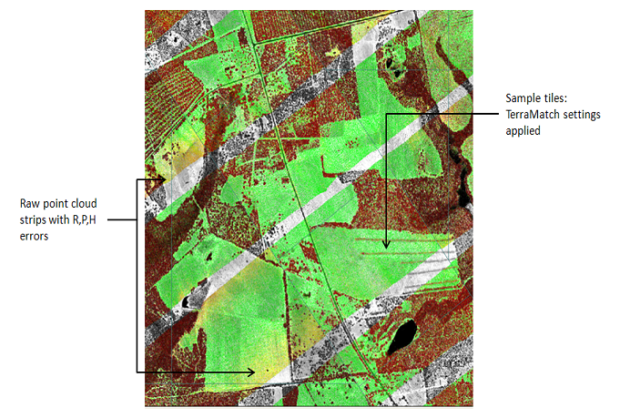
Figure 2: TerraMatch Tiling Sample

3.0 LiDAR FLIGHT AND SYSTEM REPORT

3.1 Introduction
This section addresses LiDAR system, flight reporting and data acquisition methodology used during the collection of the Lubbock campaign. Although Sanborn conducts all LiDAR acquisition with the same rigorous and strict procedures and processes, all LiDAR collections are unique.

3.2 Field Work Procedures
A minimum of two GPS base stations were set for the Lubbock project, which is within the project area or within the required baseline specifications of the project.

Pre-flight checks such as cleaning the sensor head glass are performed. A four minute INS initialization is conducted on the ground, with the engines running, prior to flight, to establish fine-alignment of the INS. GPS ambiguities are resolved by flying within ten kilometers of the base stations.

The flight missions were typically four or five hours in duration including runway calibration flights flown at the beginning and the end of each mission. During the data collection, the operator recorded information on log sheets which includes weather conditions, LiDAR operation parameters, and flight line statistics. Near the end of the mission GPS ambiguities are again resolved by flying within ten kilometers of the base stations, to aid in post-processing.

Table 2 shows the planned LiDAR acquisition parameters with a flying height of between 1500 to 1700 meters above ground level (AGL) for the Leica system on a mission to mission basis.

Table 2: LiDAR Acquisition Parameters

Average Altitude | 1500-1700 Meters AGL
Airspeed | ~120 to ~140 knots
Scan Frequency | 54.4 Hertz
Scan Width Half Angle | 20 Degrees
Pulse Rate | 80,000 Hertz

Preliminary data processing was performed in the field immediately following the missions for quality control of GPS data and to ensure sufficient overlap between flight lines. Any problematic data could then be re-flown immediately as required. Final data processing was completed in the Colorado Springs office.

Table 3: Collection Dates, Times, Average Per Flight Collection Parameters and PDOP

Mission | Date | Sensor  (Sanborn/  Keystone) | Start Time | End Time | Altitude (m) | Airspeed (Knots) | Scan Angle | Scan Rate | Pulse  Rate | PDOP  (Ave)
062 | Mar 03 | Leica ALS50-S | 11:57 | 15:00 | 4500 | 140 | 40˚ | 54.4 | 80000 | 1.4
063 | Mar 04 | Leica ALS50-S | 08:54 | 10:40 | 4500 | 140 | 40˚ | 54.4 | 80000 | 1.2
064a | Mar 05 | Leica ALS50-S | 09:23 | 13:16 | 4500 | 140 | 40˚ | 54.4 | 80000 | 1.3
064b | Mar 05 | Leica ALS50-S | 15:55 | 19:22 | 4900 | 140 | 40˚ | 54.4 | 80000 | 1.3
064c | Mar 05 | Leica ALS50-S | 09:20 | 12:50 | 1400 | 140 | 40˚ | 54.4 | 80000 | 1.2
064d | Mar 05 | Leica ALS50-S | 02:28 | 06:17 | 1400 | 140 | 40˚ | 54.4 | 80000 | 1.2
065 | Mar 06 | Leica ALS50-S | 09:53 | 12:39 | 4900 | 140 | 40˚ | 54.4 | 80000 | 1.4

3.3 Final LiDAR Processing

LiDAR filtering was accomplished using TerraSolid, TerraScan LiDAR processing and modeling software. The filtering process reclassifies all the data into classes with in the LAS formatted file based scheme set using the LAS format 1.2 specifications or by the client. Once the data is classified, the entire data set is reviewed and manually edited for anomalies that are outside the required guidelines of the product specification or contract guidelines, whichever apply. Table 4 indicates the required product specifications.

The coordinate and datum transformations are then applied to the data set to reflect the required deliverable projection, coordinate and datum systems as provided in the contract.

The client required deliverables are then generated. At this time, a final QC process is undertaken to validate all deliverables for the project. Prior to release of data for delivery, Sanborn’s quality control/quality assurance department reviews the data and then releases it for delivery.

Table 4: Processing Accuracies and Requirements

Accuracy of LiDAR Data (H) | 1m RMSE
Accuracy of LiDAR data in bare areas | 15 cm RMSE

4.0 GEODETIC authentication

4.1 Final LiDAR Verification
The LiDAR data was evaluated using a collection of 30 NGS benchmarks; see figure 3 for diagram. For Lubbock, the standard deviation is 0.228 feet and the root mean squared is 0.225 feet. The LiDAR data was compared to each of these benchmarks yielding much better result than was required for the project. Table 5 indicates the results for Lee County and each point including the overall results as it compares to the LiDAR data set.

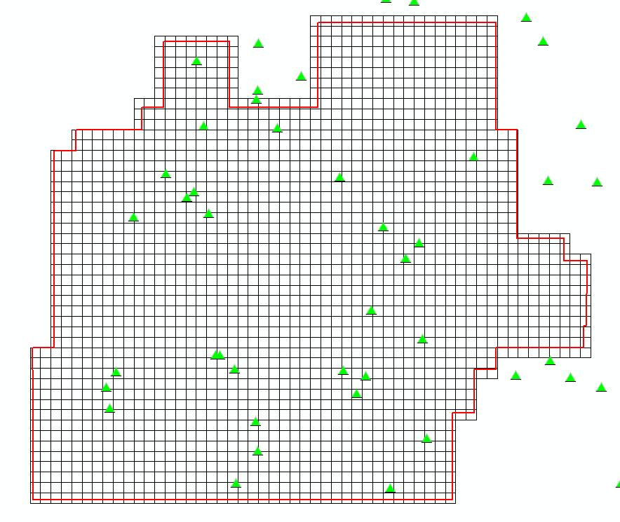

Figure 3: Lee Survey Checkpoint Diagram

Table 5: LiDAR Accuracy Assessment based on the Checkpoint Survey (Feet)

Name | Vegetation Class | Easting | Northing | Known Z | Laser Z | Dz
1 | Bare Earth | 7256473.930 | 949868.080 | 3197.840 | 3198.310 | +0.470
2 | Bare Earth | 7245765.540 | 913366.740 | 3270.950 | 3270.800 | -0.150
3 | Bare Earth | 7232867.780 | 886864.290 | 3322.190 | 3321.930 | -0.260
4 | Bare Earth | 7222581.700 | 922378.300 | 3257.060 | 3256.950 | -0.110
5 | Bare Earth | 7236470.530 | 946343.900 | 3201.940 | 3201.770 | -0.170
6 | Bare Earth | 7285032.420 | 907131.790 | 3307.120 | 3307.120 | +0.000
7 | Bare Earth | 7268963.280 | 958076.090 | 3180.780 | 3181.080 | +0.300
8 | Bare Earth | 7225701.250 | 963107.420 | 3169.540 | 3169.100 | -0.440
9 | Bare Earth | 7307289.690 | 922135.990 | 3262.370 | 3262.590 | +0.220
10 | Bare Earth | 7289418.360 | 900292.310 | 3319.520 | 3319.560 | +0.040
11 | Bare Earth | 7245780.570 | 912287.830 | 3283.890 | 3283.730 | -0.160
12 | Bare Earth | 7241706.410 | 888385.460 | 3325.420 | 3325.340 | -0.080
13 | Bare Earth | 7214829.410 | 917195.560 | 3253.500 | 3253.900 | +0.400
14 | Bare Earth | 7240687.150 | 948405.750 | 3195.930 | 3195.970 | +0.040
15 | Bare Earth | 7283793.570 | 905412.620 | 3311.820 | 3312.030 | +0.210
16 | Bare Earth | 7272714.710 | 961386.720 | 3178.810 | 3178.840 | +0.030
17 | Bare Earth | 7272714.710 | 961386.720 | 3178.810 | 3178.840 | +0.030
18 | Bare Earth | 7249586.760 | 962096.080 | 3166.080 | 3165.950 | -0.130
19 | Bare Earth | 7293518.150 | 974535.470 | 3187.290 | 3187.240 | -0.050
20 | Bare Earth | 7301010.540 | 909417.700 | 3280.180 | 3280.160 | -0.020
21 | Bare Earth | 7300430.910 | 927230.950 | 3243.620 | 3243.370 | -0.250
22 | Bare Earth | 7242316.300 | 916956.850 | 3277.580 | 3277.440 | -0.140
23 | Bare Earth | 7238014.770 | 885966.060 | 3329.760 | 3329.570 | -0.190
24 | Bare Earth | 7229742.330 | 922021.310 | 3265.470 | 3265.270 | -0.200
25 | Bare Earth | 7242068.570 | 943078.160 | 3208.270 | 3208.390 | +0.120
26 | Bare Earth | 7279900.440 | 910564.780 | 3305.100 | 3305.370 | +0.270
27 | Bare Earth | 7276579.800 | 952767.380 | 3193.550 | 3193.780 | +0.230
28 | Bare Earth | 7213707.130 | 954315.390 | 3180.630 | 3180.650 | +0.020
29 | Bare Earth | 7316675.740 | 907843.340 | 3316.260 | 3316.180 | -0.080
30 | Bare Earth | 7278925.270 | 892642.500 | 3329.760 | 3330.220 | +0.460
31 | Bare Earth | 7288562.890 | 942288.780 | 3218.270 | 3218.510 | +0.240
Average dz |  | +0.021
Minimum dz |  | -0.440
Maximum dz |  | +0.470
Average Magnitude |  | 0.183
Root Mean Square |  | 0.225
Std deviation |  | 0.228

5.0 Coordinates and Datum

5.1 Introduction
The final adjustment was constrained to the published NAD83 geodetic coordinates (φ, λ) and NAVD88 elevations. The adjustment was cross-referenced to the GEOID03 model to enable the estimation of orthometric heights.

5.2 Horizontal Datum
The final horizontal coordinates are provided in State Plane Texas North Central FIPS 4204 on the North American Datum of 1983 (NAD83 adjustment of 1992) units of feet.

5.3 Vertical Datum
The final orthometric elevations were determined for all points in the network using Geoid03 model and are provided on the North American Vertical Datum of 1988 in units of feet.

